Crime as a Reliability Problem

Janine White, Travis Schmidt

IEE573 Reliability Engineering Term Project

Dr. Rong Pan

December 5, 2016

Table of Contents

Introduction 2

2014 Arrestees 3

Arrestees by Sex 7

Arrestees by Injury 9

Discussion 12

References 13

# Introduction

The Age-Crime Curve is taken as a fact in criminology. The age of people arrested for crimes has a distinctive distribution, rising through the teens, peaking in the mid-twenties to early thirties and declining thereafter. While this bell shape varies, for example, by sex of offender and type of crime, or may be truncated by opportunity, the general distribution holds. We will use reliability engineering principles to examine the properties of the age-crime curve and discuss how they relate to theories of crime.

**Chart 1. 2014 Age Crime Curve**

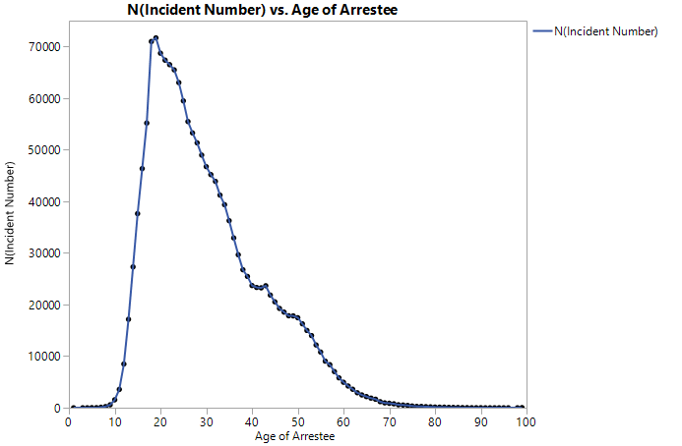

The data used in this study is the 2014 Uniform Crime Reporting Program Data of the United States Department of Justice Federal Bureau of Investigation as reported to the National Incident-Based Reporting System (NIBRS).[1] NIBRS is a compilation of offenses known to the police. However, many crimes are not reported to the police, for example, fear of reprisal or getting the offender in trouble, police would not or could not help, the crime is not considered important enough to report, and offenses were dealt with in another way or as a personal matter, leading to 58% of crimes not being reported to the police when evaluated in victimization studies.[2] The offender data is available for anyone identified as a perpetrator whether or not they were arrested or convicted. Each offender and arrestee record identify which crime the record is associated with and demographics of the offender or arrestee if known. Unique identifiers are not provided to track individual offenders or arrestees across incidences. However, although offender data provides a larger pool of data that is likely to be less biased, many records provide incomplete data because the offenders are unknown. Arrestee data provides consistent demographic and incident data and is used for this analysis. According to the US census bureau, the population of the US as of July 1, 2015, was 321,418,820, of which 50.8% were female, 6.2% were under 5 years of age, 22.9% were under 18 years, and 14.9% were 65 years.[3] In the arrestee data, there were 1068907 incidents in 2014 with a mean of 1.3 arrestees, with 10% involving 2 or more arrestees, the average age of arrestee was 30.1 with a standard deviation of 12.1, and 70.8% were male. Note that 2039 records (0.19%) were excluded from the analysis because the age of the arrestee was unknown. For consideration of the age crime curve as a reliability problem, the age at which a person is arrested for crime is considered the time of failure.

# 2014 Arrestees

The distribution wizard in Reliasoft Weibull++ found that the G-Gamma distribution was the best fit for the age crime distribution using MLE. Table 1 shows the ranking of the distributions considered and Table 2 shows estimated parameters. The parameter estimates for the top ranking distribution, G-Gamma, are $μ$ = 3.298362, $σ$ = 0.390656, and $λ$ = -0.149254. The generalized gamma distribution is typically represented as a three parameter distribution using $k$, $β$, and $θ$, represented as:

$$f(t)=\frac{β}{Γ\left(k\right)∙θ}{\left(\frac{t}{θ}\right)}^{kβ-1}e^{-{\left(\frac{t}{θ}\right)}^{β}}$$

However, Weibull++ reports the parameters using an alternative form where $μ=\ln\left(θ\right)+\frac{1}{β}∙\ln\left(\frac{1}{λ^{2}}\right)$, $σ=\frac{1}{β\sqrt{k}}$, and , gives

.[4]

By inspection of the Probability- G-Gamma plot, the data fit best for arrestees between 7 and 59 years, which contains 98.1% of the data. The highest point of the PDF occurs at 23 years, representing the most likely age of arrest.

**Table 1. Distribution Ranking**

|  |  |  |  |  |  |  |  |  |
| --- | --- | --- | --- | --- | --- | --- | --- | --- |
| **Distribution** | **Rank** | **AVGOF** | **AVPLOT** | **LKV** | **RAVGOF** | **RAVPLOT** | **RLKV** | **DESV** |
| G-Gamma | 1 | 2.352277 | 1.132569 | -6345071 | 1 | 2 | 1 | 110 |
| Lognormal | 2 | 6.117685 | 1.125573 | -6347201 | 2 | 1 | 2 | 190 |
| Gamma | 3 | 28.85928 | 1.355029 | -6372117 | 4 | 3 | 3 | 340 |
| Loglogistic | 4 | 8.516328 | 1.56279 | -6393917 | 3 | 4 | 4 | 360 |
| 3P-Weibull | 5 | 49.18361 | 1.938816 | -6452013 | 6 | 5 | 5 | 540 |
| 2P-Weibull | 6 | 51.58084 | 2.009259 | -6460866 | 7 | 6 | 6 | 640 |
| Logistic | 7 | 40.22715 | 2.32465 | -6525599 | 5 | 7 | 8 | 670 |
| Normal | 8 | 78.54133 | 2.598924 | -6520274 | 8 | 8 | 7 | 750 |
| Gumbel | 9 | 98.0646 | 4.648514 | -6841703 | 9 | 9 | 9 | 900 |
| 2P-Exponential | 10 | 100 | 10.86365 | -7279135 | 10 | 10 | 10 | 1000 |
| 1P-Exponential | 11 | 100 | 11.46373 | -7335369 | 11 | 11 | 11 | 1100 |

**Table 2. Distribution Estimated Parameters**

|  |  |  |  |
| --- | --- | --- | --- |
| **Distribution** | **Parameter Estimation** | | |
| G-Gamma | Mean=3.2983619215115 | Std=0.390656045823703 | Lambda=-0.149253810607195 |
| Lognormal | LMean=3.32762079284862 | LStd=0.392610634164706 |  |
| Gamma | Mu=1.51481743990872 | K=6.62082095741867 |  |
| Loglogistic | Mu=3.32077874543703 | Sigma=0.231563492988729 |  |
| 3P-Weibull | Beta=2.5608367838334 | Eta=32.9767873059789 | Gamma=0.917499999999998 |
| 2P-Weibull | Beta=2.63637648798306 | Eta=33.9705101485771 |  |
| Logistic | Mu=28.8837620557895 | Sigma=6.87241455271698 |  |
| Normal | Mean=30.1154073658603 | Std=12.1413605394688 |  |
| Gumbel | Mu=36.6120945172995 | Sigma=14.1431023804486 |  |
| 2P-Exponential | Lambda=0.0343460762006224 | Gamma=1 |  |
| 1P-Exponential | Lambda=0.033205594327561 |  |  |

**Table 3. 3 Parameter G-Gamma Estimates**

|  |  |
| --- | --- |
| **Parameters** | |
| Distribution: | G-Gamma-3P |
| Analysis: | MLE |
| CB Method: | LRB |
| Ranking: | K-M |
| Mu (yr) | 3.298362 |
| Sigma | 0.390656 |
| Lambda | -0.149254 |
| LK Value | -6.35E+06 |
| Fail \ Susp | 1665223 \ 0 |

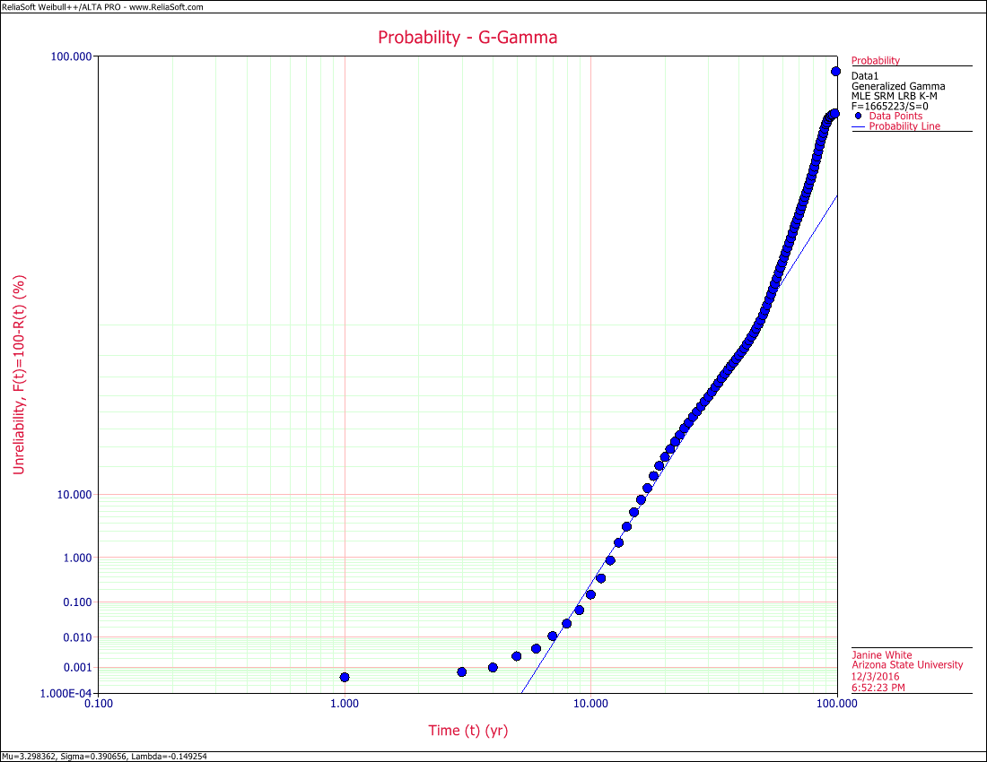 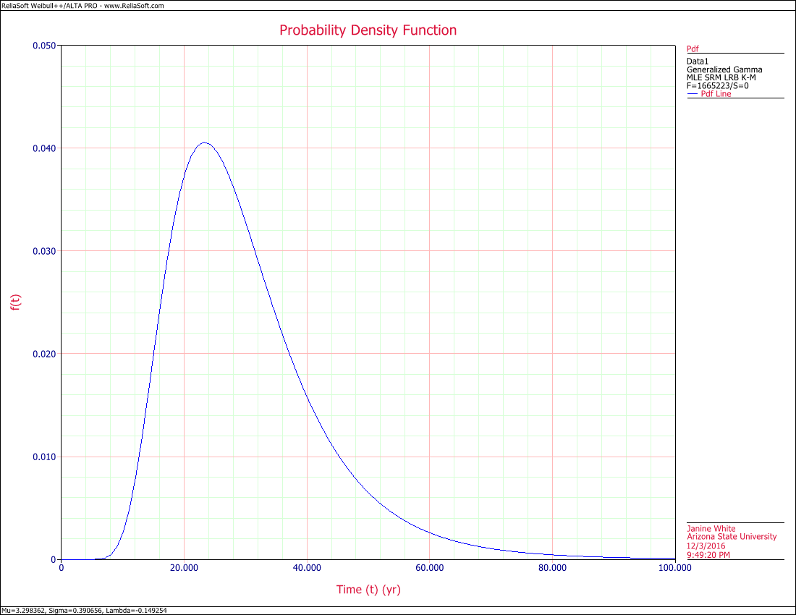

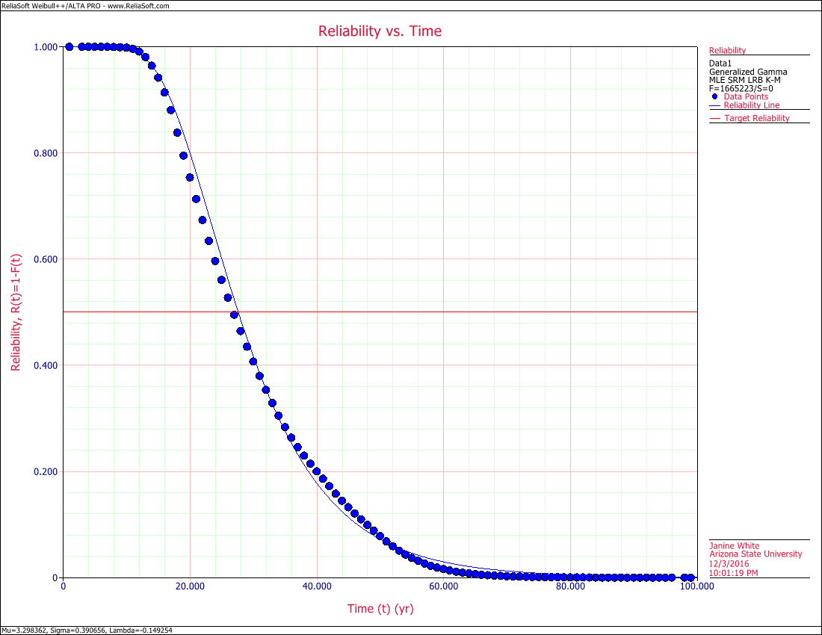 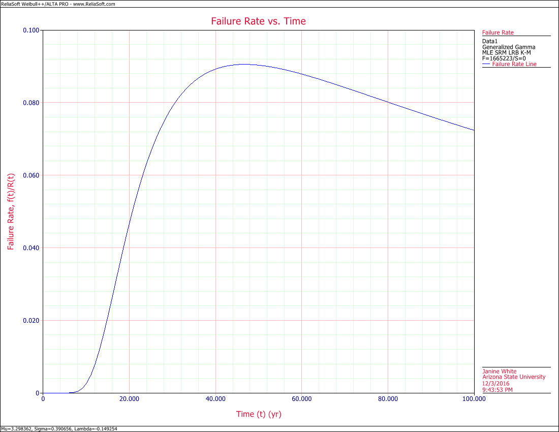

The G-Gamma distribution can represent several other distributions as special cases, so it’s important to also consider how well the lognormal distribution matches the age crime data. Graphically, the data shows a closer match to the lognormal distribution than the G-Gamma distribution. For the lognormal distribution, $T'$ is the natural logs of the times to failure. The lognormal parameters, scale = mean of the natural logarithms of the times-to-failure = $μ^{t}$ = 3.32761 and shape = standard deviation of the natural logarithms of the times to failure = $σ_{T'}$ = 0.392611. The mean time to failure (MTTF) = $e^{μ^{t}}$ = 27.87 years with standard deviation $e^{σ_{T'}}$ = 1.48. The lognormal PDF is given by:

.[5]

The likelihood function value is nearly identical between the G-Gamma and lognormal distributions are nearly identical. The lognormal distribution is more useful because it is a simpler, more easily interpretable solution.

**Table 4. Lognormal Estimates**

|  |  |  |  |
| --- | --- | --- | --- |
| **Parameters** | | | |
| Distribution: | Lognormal-2P |  |
| Analysis: | MLE |  |
| CB Method: | LRB |  |
| Ranking: | K-M |  |
| Log-Mean (yr) | 3.327621 |  |
| Log-Std | 0.392611 |  |
| LK Value | -6.347201E+6 |  |
| Fail \ Susp | 1665223 \ 0 |  |
| **LOCAL VAR/COV MATRIX** | | | |
|  | Var-LnMu=9.256605E-08 | LnCoVar=-3.937114E-22 |
|  | LnCoVar=-3.937114E-22 | Var-LnSigma=4.628307E-08 |

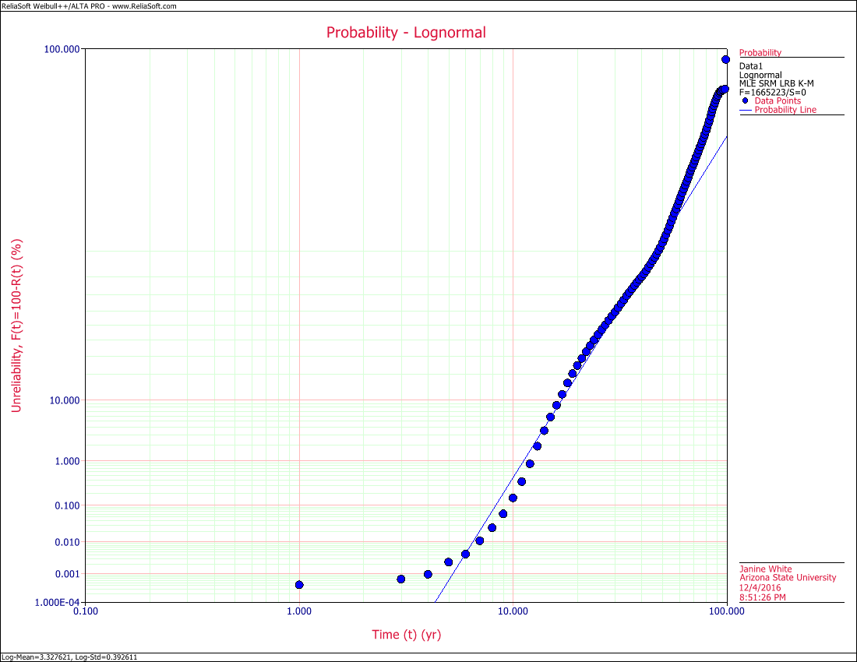 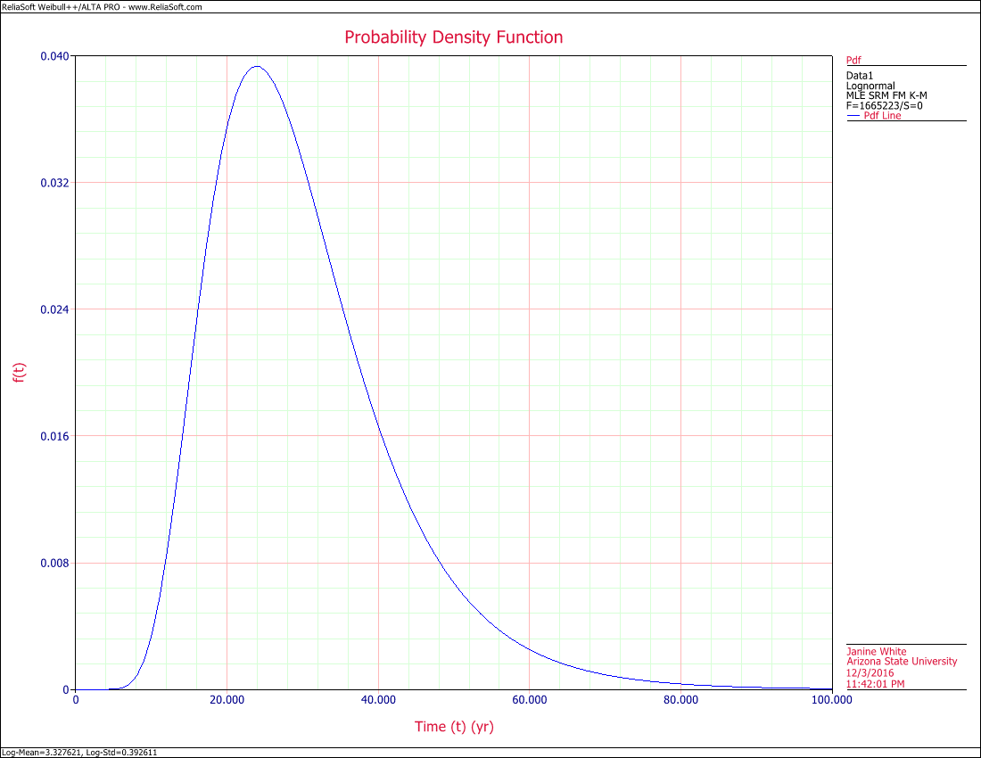

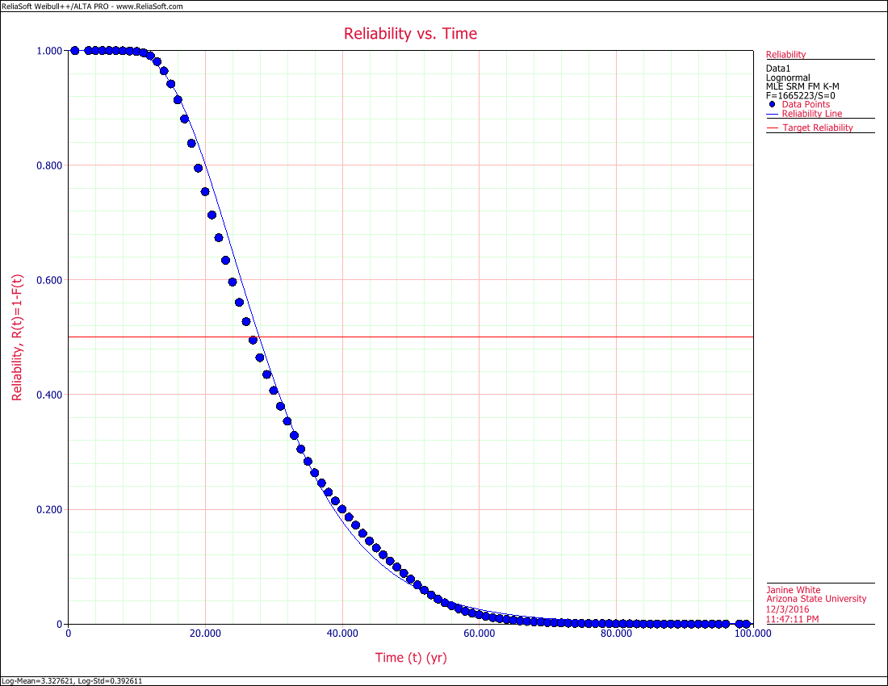 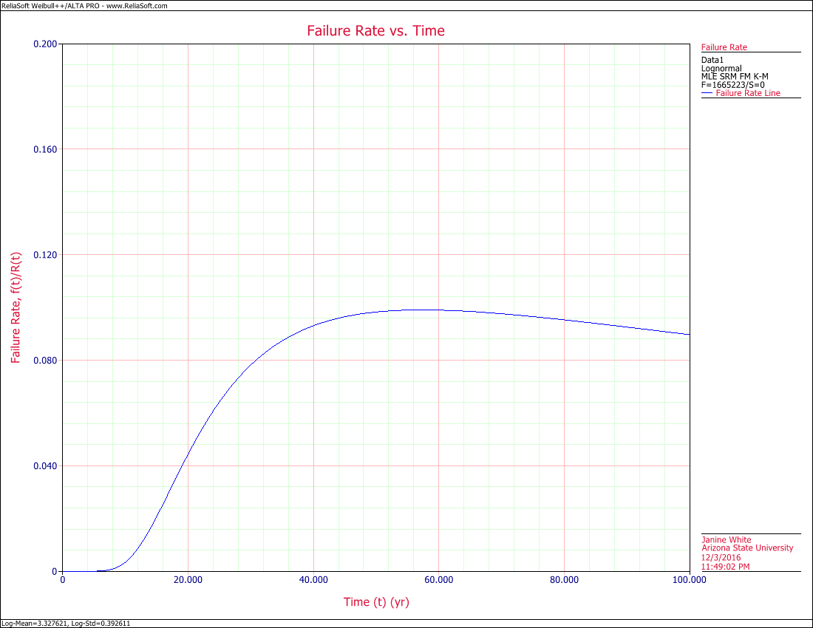

# Arrestees by Sex

The data were also analyzed separately by sex. Females fit a lognormal distribution best following G-Gamma. Males fit the Gamma and Lognormal distributions, but the likelihood values are nearly identical for both, so the lognormal distribution is used for comparison. Both distributions peak at approximately the same age, females at 27.91 and males at 27.86, but they are within each other’s standard deviations. Although men are more likely to be arrested, with a PDF peaking higher than females.

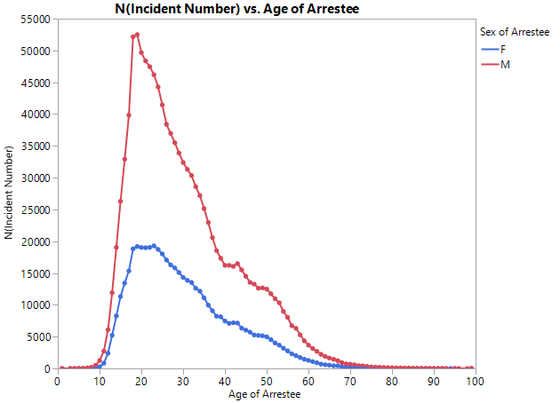

**Table 5. Female and Male Lognormal Parameters**

|  |  |  |
| --- | --- | --- |
| **Parameters** | | |
| Distribution: | Lognormal-2P | |
| Analysis: | MLE | |
| CB Method: | LRB | |
| Ranking: | K-M | |
| Sex | Female | Male |
| Log-Mean (yr) | 3.328824 | 3.327124 |
| Log-Std | 0.383579 | 0.39628 |
| LK Value | -1.84E+06 | -4.50E+06 |
| Fail \ Susp | 486731 \ 0 | 1178492 \ 0 |

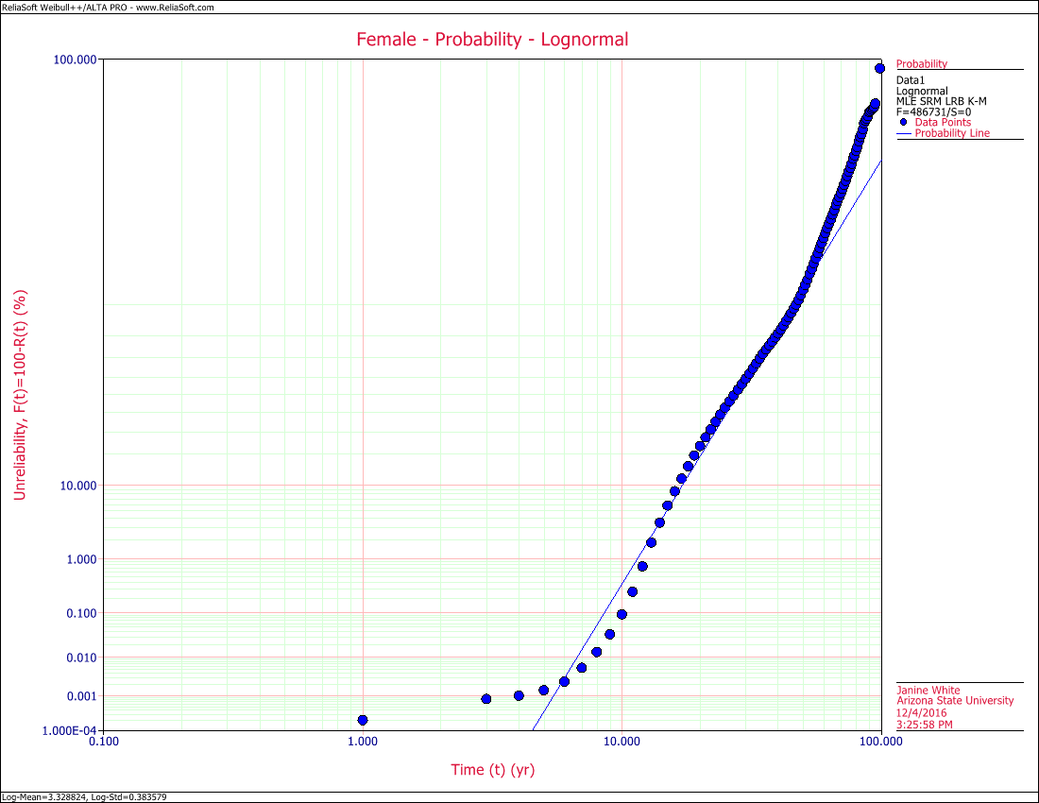 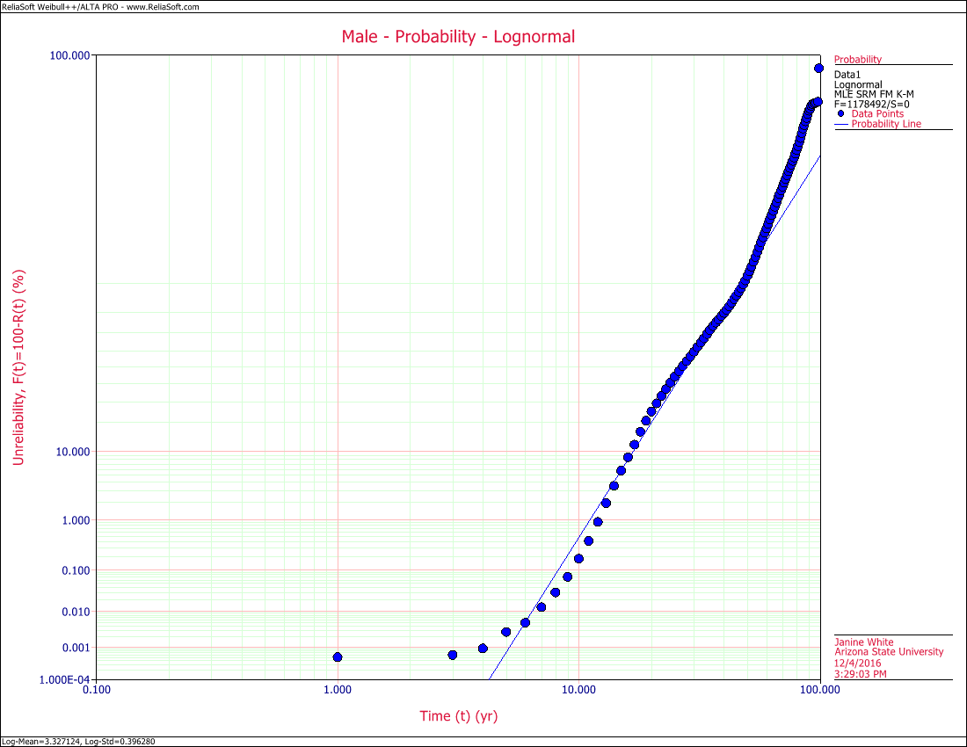

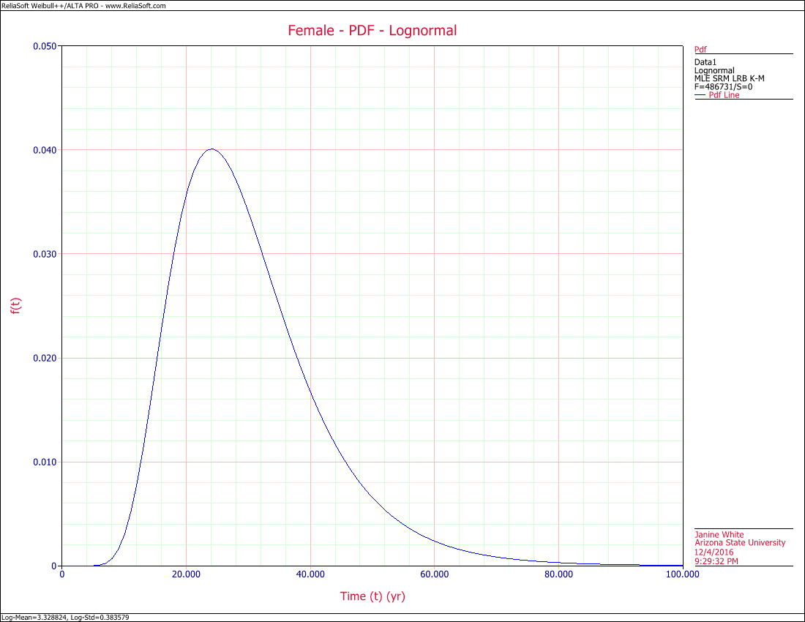 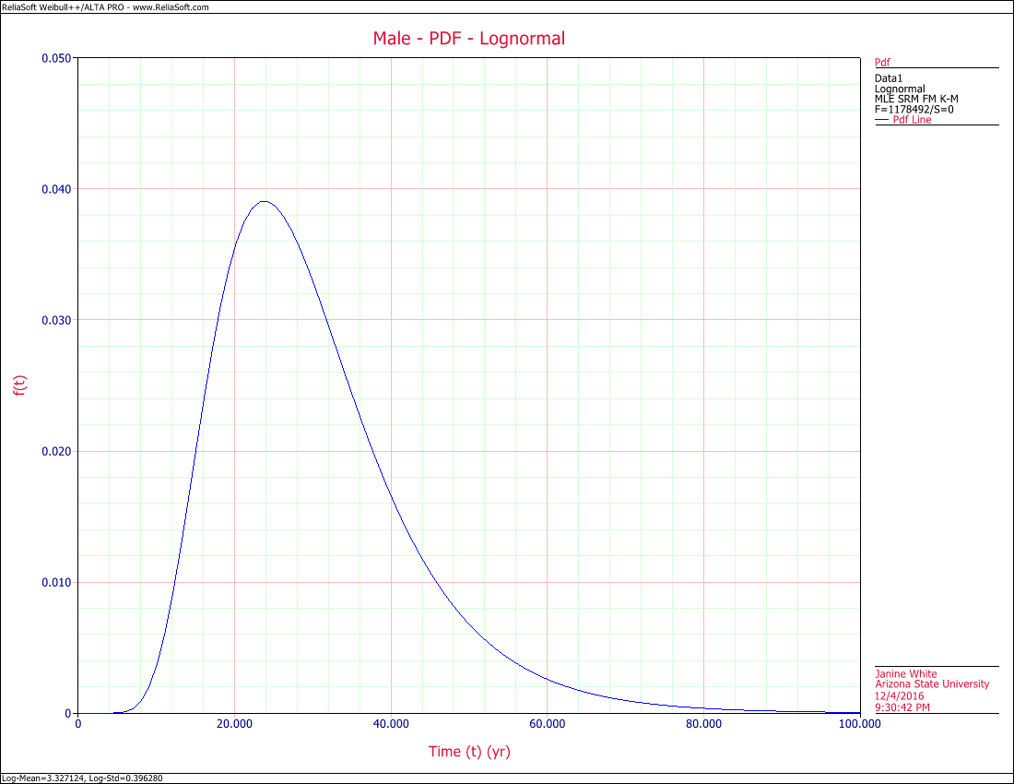

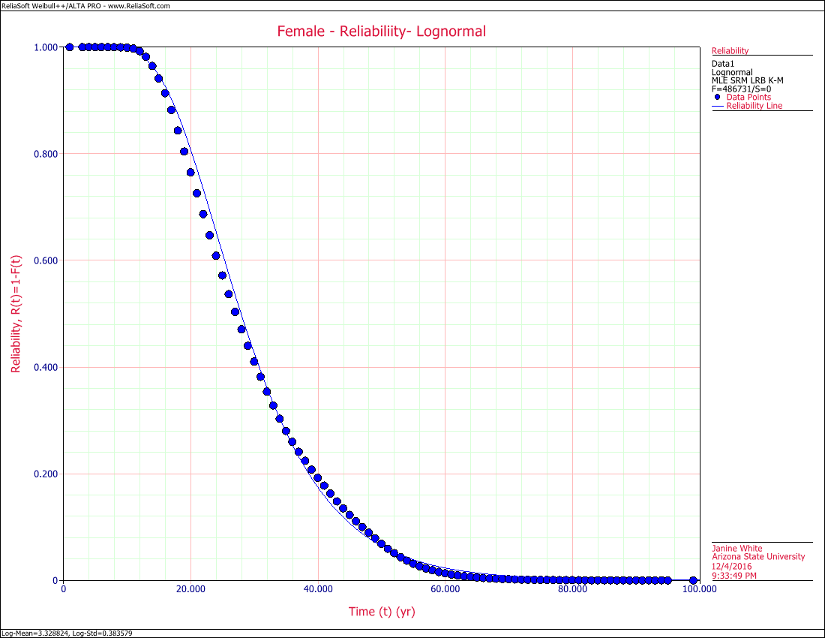 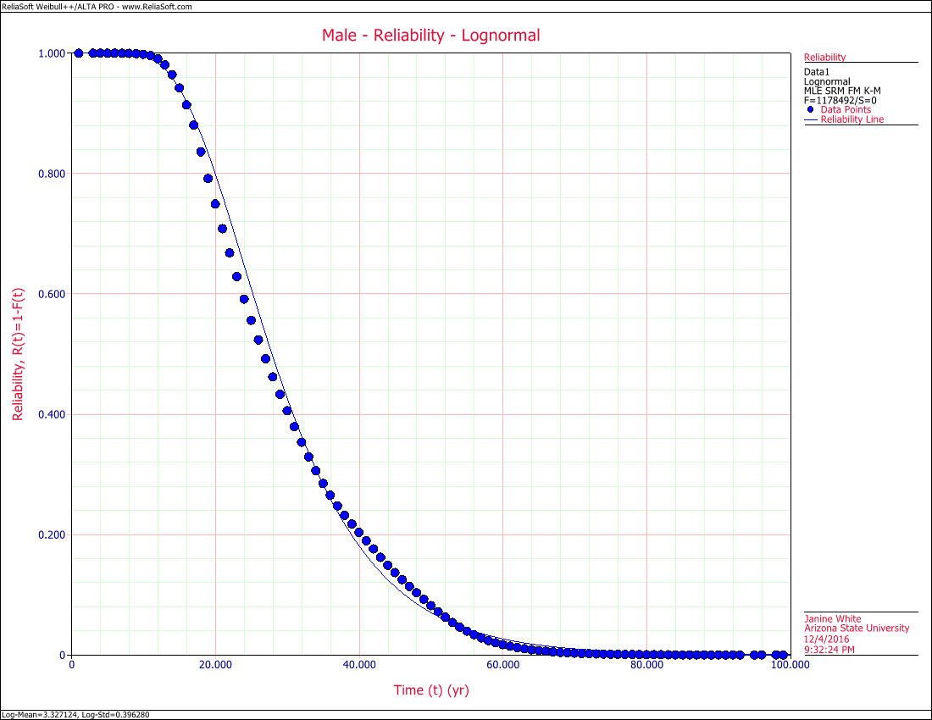

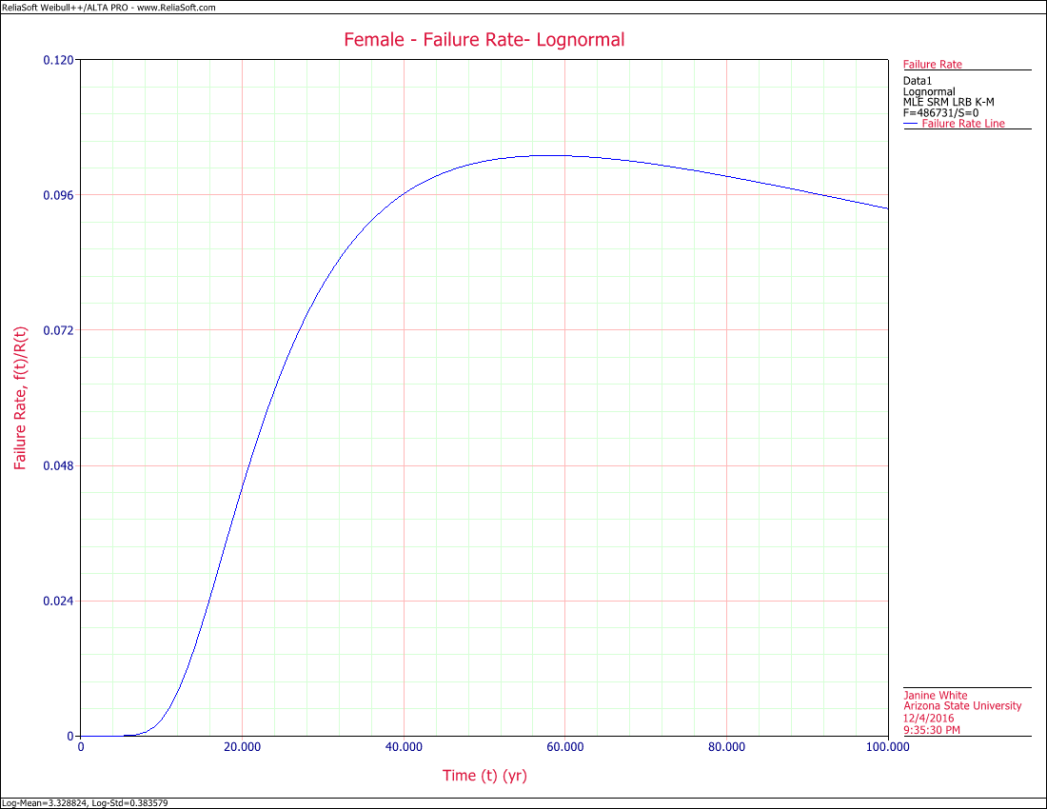 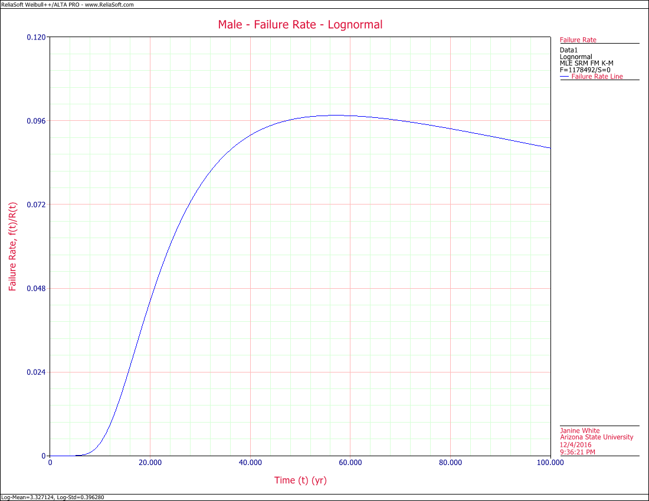

# Arrestees by Injury

Most of the arrests fall into three categories, drug violations, theft and assault/intimidation. What people are more likely to be arrested for offenses that are severe enough to come to the attention of the police are for offenses for which there are incentives to the police. Assault and theft often have severe physical and economic consequences to the victims, providing incentive to report and have the cases pursued. Drug offenses often lead to seized property that benefits law enforcement. Arrestees in cases in these categories are also typically socioeconomically disadvantaged, making them easier to prosecute successfully.

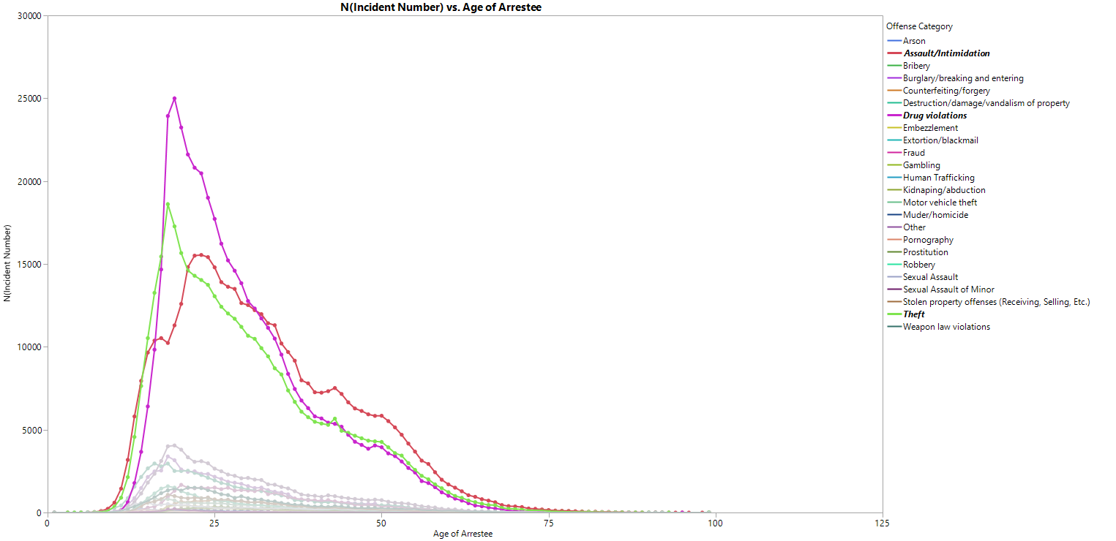

To evaluate whether the severity of the crime may impact the results, we looked at incidents where the victim was injured, coded as 1, compared to incidents where the victim was not injured, coded as 0. The relationship of uninjured to injured is similar to male to female. The uninjured distribution peaks higher and narrower, but the underlying PDF is well modeled by a lognormal distribution between 6 years and 60 years of age.

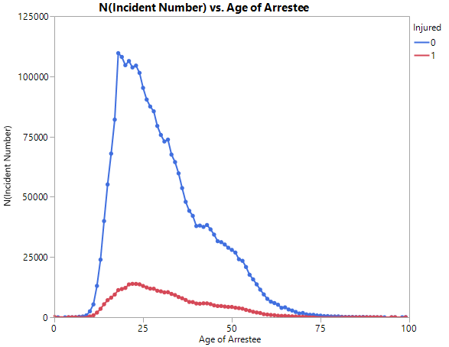

**Table 6. Uninjured and Injured Lognormal Parameters**

|  |  |  |
| --- | --- | --- |
| **Parameters** | | |
| Distribution: | Lognormal-2P | |
| Analysis: | MLE | |
| CB Method: | LRB | |
| Ranking: | K-M | |
| Sex | No Injury | Injured |
| Log-Mean (yr) | 3.341328 | 3.370325 |
| Log-Std | 0.390345 | 0.390985 |
| LK Value | -1.02E+07 | -1.40E+06 |
| Fail \ Susp | 2658937 \ 0 | 362435 \ 0 |

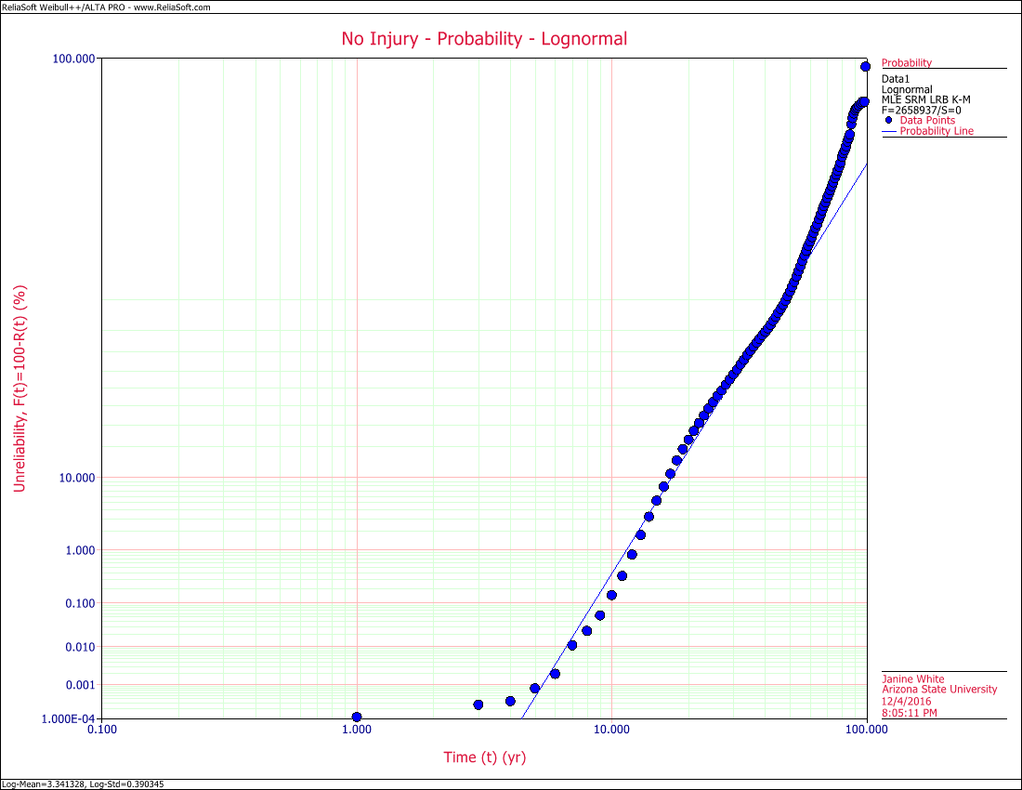 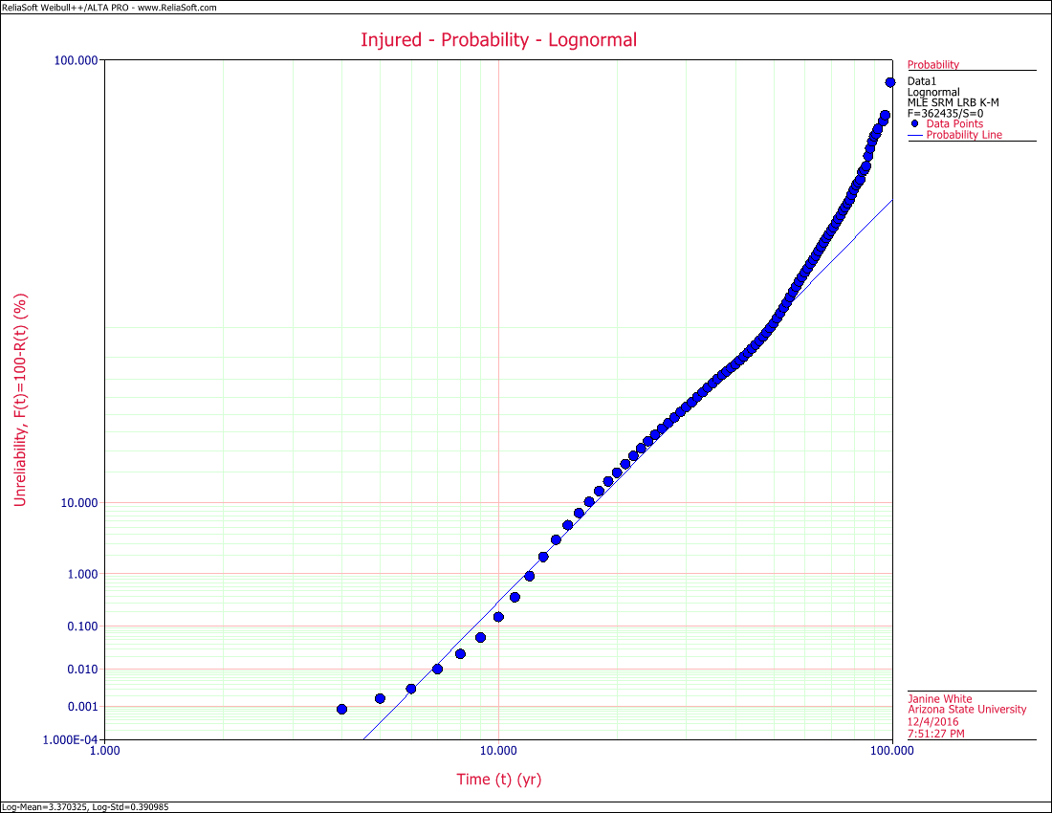

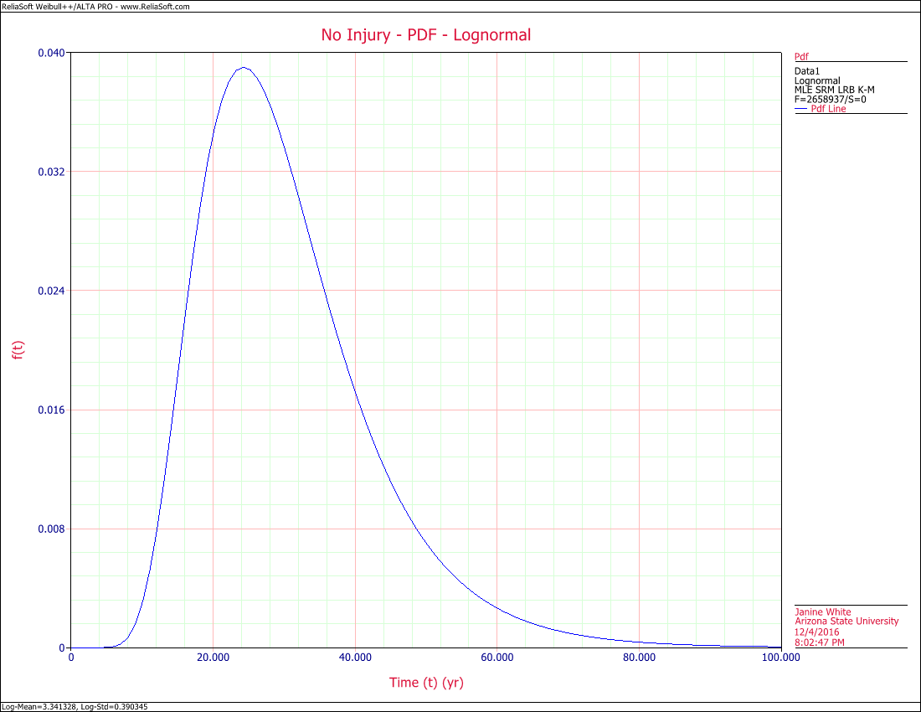 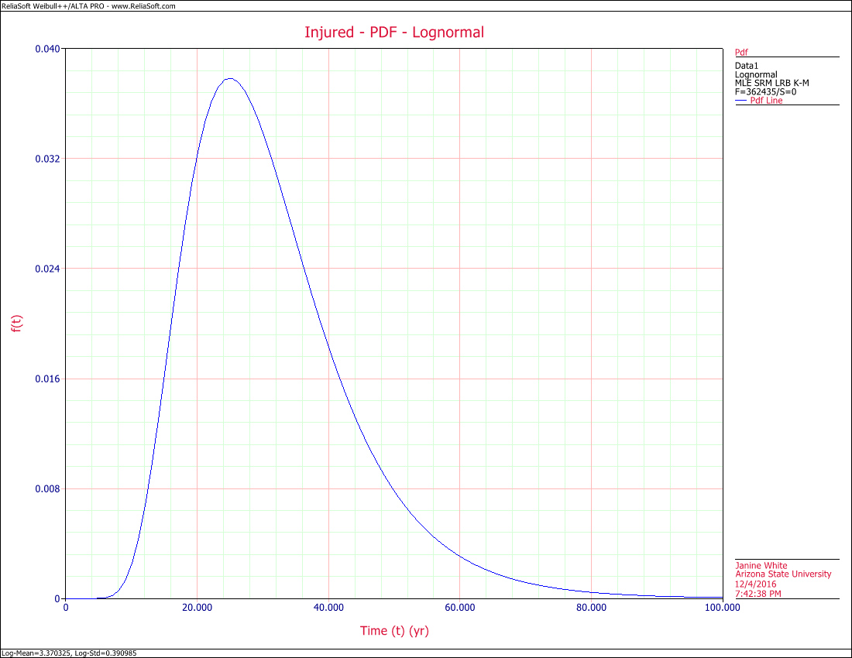

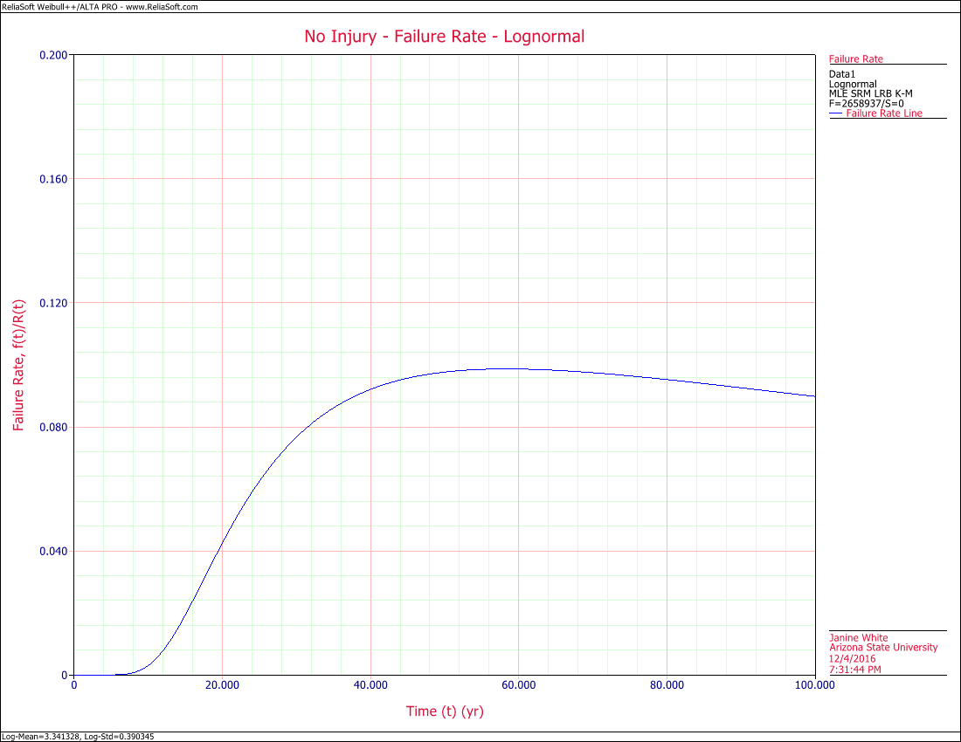 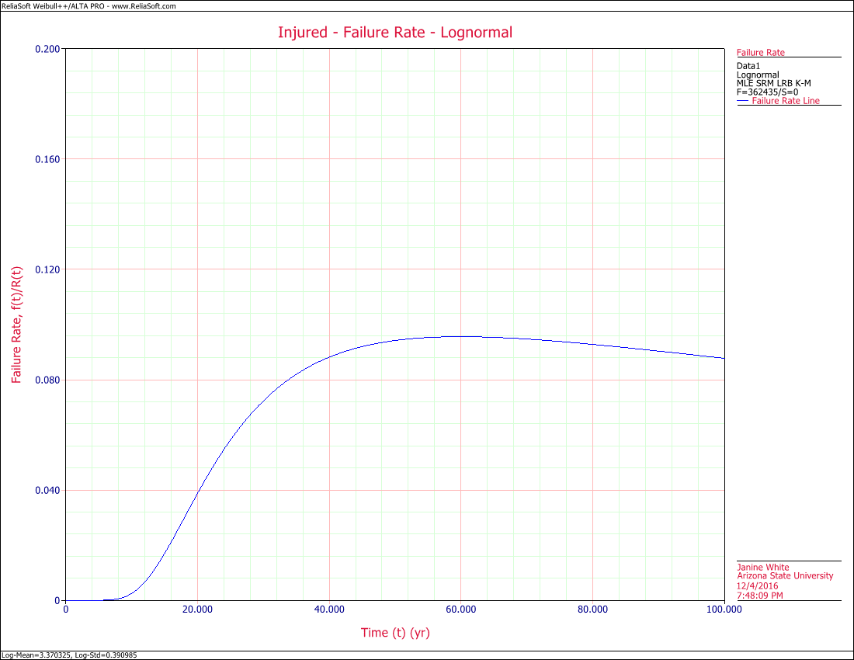

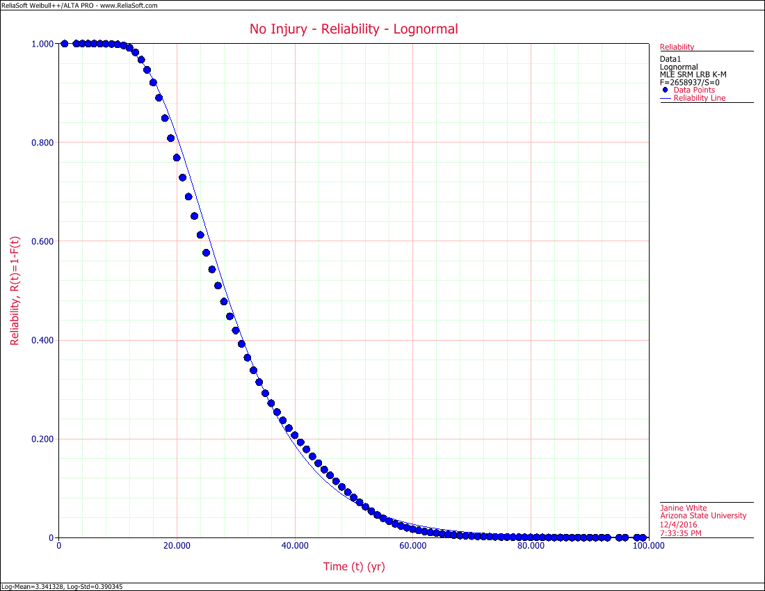 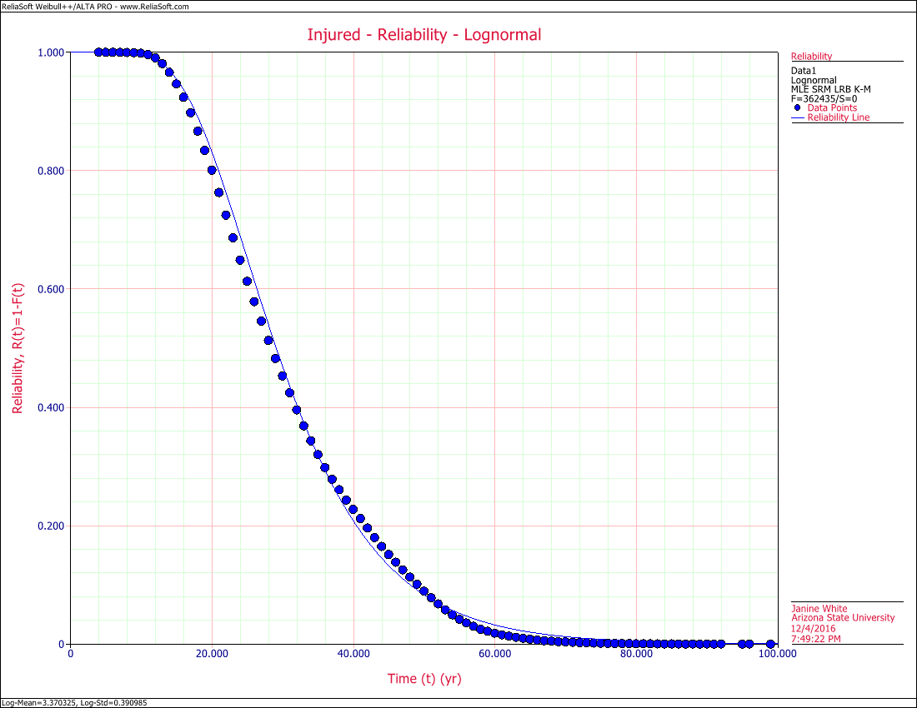

# Discussion

The constancy of the shape of the age crime curve and its PDF across sexes and crimes indicates that it may be basic to the human condition. The criminology theory most closely associated with age crime curve is Self Control Theory by Michael Gottfredson and Travis Hirschi in A General Theory of Crime.[6] Self Control Theory posits that crime is a result of the combination of opportunity and self control. Although children have low self control, until they mature they have limited opportunity to commit crime. Children are limited in their physical capabilities and closely monitored. As people mature through their teens yeas they still have low self control, but gain more freedom. The human brain typically doesn’t fully mature until age 25[7], which corresponds closely to the peak of the age crime curve. Changes in hormones as people age may also have an influence on the ability for people to master their self control, for example, testosterone has a similar trajectory to the age crime curve, including the differences between males and females which rise rapidly through adolescence and decline slowly after age 30.[8] The graphs below show the normal range for testosterone in males and females from the Mayo Clinic. Attachment theory[9] in psychology and social control theory[10] in sociology posit that attachments to others shape their personality and socialization, counteracting the tendency to anti-social behavior. Initial attachment to parents in childhood could help explain the control of behavior in children. As people age, they tend to develop adult relationships in public and private spheres that act as disincentives to anti-social behavior. A combination of biological, psychological, and sociological factors is likely to shape the human experience to create the characteristics of the age crime curve.

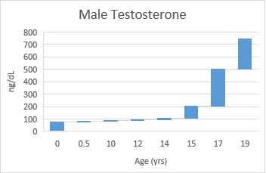 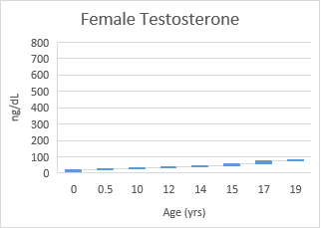

# References

“Brain Maturity Extends Well Beyond Teen Years.” Tell Me More. National Public Radio 10/10/2011. Web. <[http://www.npr.org/templates/story/story.php?storyId=141164708](http://www.npr.org/templates/story/story.php?storyId=141164708%20)>

"Characteristics of the Lognormal Distribution." *Reliability HotWire*.47 (January 2005) Web. <<http://www.weibull.com/hotwire/issue47/relbasics47.htm>>

"The Generalized Gamma Distribution and Reliability Analysis." *Reliability HotWire*.15 (May 2002) Web. <[http://www.weibull.com/hotwire/issue15/hottopics15.htm](http://www.weibull.com/hotwire/issue15/hottopics15.htm%20)>

Gottfredson, Michael and Hirschi, Travis. 1990. A General Theory of Crime. Stanford University Press. 316 pp.

Hirschi, Travis. 1969. Causes of Delinquency. Berkeley, CA: University of California Press. 309 pp.

Langston, Lynn, et al. *Special Report, National Crime Victimization Survey, Victimizations Not Reported to the Police, 2006-2010*. NCJ238536 Vol. U.s. Department of Justice, Office of Justice Programs,Bureau of Justice Statistics, 2012. Web. 11/26/2016. <<https://www.bjs.gov/content/pub/pdf/vnrp0610.pdf>>

Severson, Alexia, and Barclay, R. Sam. “Testosterone Levels by Age.” Healthline. Kim, Steven, M.D., ed. 3/23/2015. Web. <<http://www.healthline.com/health/low-testosterone/testosterone-levels-by-age>>

Thompson, Rose. March 2013. “Attachment Theory and Research: Précis and Prospect.” The Oxford Handbook of Developmental Psychology, Vol. 2: Self and Other. Web. <<http://www.oxfordhandbooks.com/view/10.1093/oxfordhb/9780199958474.001.0001/oxfordhb-9780199958474-e-009>>

United States Census Bureau. "United States Quick Facts." Web. <<https://www.census.gov/quickfacts/table/PST045215/00>>.

United States Department of Justice, Federal Bureau of Investigation. "Uniform Crime Reporting Program Data: National Incident-Based Reporting System, 2014 (ICPSR 36398)." *National Archive of Criminal Justice Data.* Inter-university Consortium for Political and Social Research. 3/21 2016. Web. <<http://www.icpsr.umich.edu/icpsrweb/NACJD/studies/36398>>.

1. United States Department of Justice, Federal Bureau of Investigation. "Uniform Crime Reporting Program Data: National Incident-Based Reporting System, 2014 (ICPSR 36398)." *National Archive of Criminal Justice Data.* Inter-university Consortium for Political and Social Research. 3/21 2016. Web. <<http://www.icpsr.umich.edu/icpsrweb/NACJD/studies/36398>>.
2. Langston, Lynn, et al. *Special Report, National Crime Victimization Survey, Victimizations Not Reported to the Police, 2006-2010*. NCJ238536 Vol. U.s. Department of Justice, Office of Justice Programs,Bureau of Justice Statistics, 2012. Web. 11/26/2016. <<https://www.bjs.gov/content/pub/pdf/vnrp0610.pdf>>
3. United States Census Bureau. "United States Quick Facts." Web. <<https://www.census.gov/quickfacts/table/PST045215/00>>.
4. "The Generalized Gamma Distribution and Reliability Analysis." *Reliability HotWire*.15 (May 2002) Web. <[http://www.weibull.com/hotwire/issue15/hottopics15.htm](http://www.weibull.com/hotwire/issue15/hottopics15.htm%20)>.
5. "Characteristics of the Lognormal Distribution." *Reliability HotWire*.47 (January 2005) Web. <<http://www.weibull.com/hotwire/issue47/relbasics47.htm>>.
6. Gottfredson, Michael and Hirschi, Travis. 1990. A General Theory of Crime. Stanford University Press. 316 pp.
7. “Brain Maturity Extends Well Beyond Teen Years.” Tell Me More. National Public Radio 10/10/2011. Web. <[http://www.npr.org/templates/story/story.php?storyId=141164708](http://www.npr.org/templates/story/story.php?storyId=141164708%20)>.
8. Severson, Alexia, and Barclay, R. Sam. “Testosterone Levels by Age.” Healthline. Kim, Steven, M.D., ed. 3/23/2015. Web. <<http://www.healthline.com/health/low-testosterone/testosterone-levels-by-age>>.
9. Thompson, Rose. March 2013. “Attachment Theory and Research: Précis and Prospect.” The Oxford Handbook of Developmental Psychology, Vol. 2: Self and Other. Web. <<http://www.oxfordhandbooks.com/view/10.1093/oxfordhb/9780199958474.001.0001/oxfordhb-9780199958474-e-009>>.
10. Hirschi, Travis. 1969. Causes of Delinquency. Berkeley, CA: University of California Press. 309 pp.